

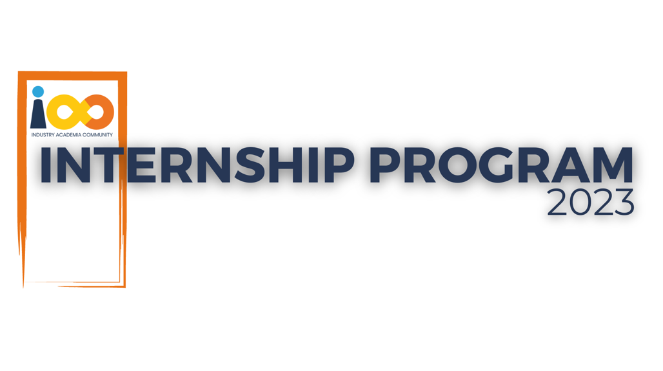

PROJECT REPORT

<Web Development>  
  
<College Search Website>

|  |  |  |  |
| --- | --- | --- | --- |
| **Created By:** | Rushabh Shah | **Approved By:** | Harshada Topale |
| **Created On:** | 25-10-2023 | **Approved On:** | DD-MMM-YYYY |

Page left blank intentionally

**INDEX**

**1** **PROJECT DETAILS** 2

**2** **SUMMARY** 2

**3** **INTRODUCTION** 2

3.1 Background 2

3.2 Stakeholders 2

3.3 Objectives 2

**4** **METHODOLOGY** 2

4.1 Considerations & Assumption 3

4.2 Approach 3

4.3 Activities 3

**5** **TARGETTED V/S ACHIEVED OUTPUT** 3

**6** **CONCLUSION** 3

**7** **APPENDICES** 4

7.1 Appendix A – Title 4

**General Instructions for using the Live Project Report Template**

* This template and the subsequent document created using this template is a confidential document and is the intellectual property of Cloud Counselage Pvt. Ltd. Circulating it outside of the organisation without the consent of Cloud Counselage Pvt. Ltd. is the breach of company policies and will lead to legal actions
* This template is a guideline document to communicate the implementation of design ideas and the results of the work to the stakeholders.
* The **text between inequality (< >) is to be replaced** by relevant text
* Please **remove the yellow highlight on the Text** between the inequality (< >). This is done to help you notice the text to be changed/replaced
* The text in *italics* highlighted in grey is just for reference and should be removed after adding the relevant text

# **PROJECT DETAILS**

|  |  |  |  |
| --- | --- | --- | --- |
| **Project Name** | College Search Website | | |
| **Project Sponsor** | Tushar Topale | | |
| **Project Manager** | Harshada Topale | | |
| **Start Date** | DD-MMM-YYYY | **Completion Date** | 25-10-2023 |

# **SUMMARY**

*<Explain what the project was expected to deliver, why the project was needed and what the long-term benefits have been or will be. Even though a summary is placed at the beginning of a project report, you can only write it once your entire report is complete.>*

1. < Is an application designed to assist students and parents in finding suitable colleges based on a variety of search criteria. The application will provide a user-friendly interface that allows users to input their preferences and then receive a curated list of colleges that match their criteria.>

# **INTRODUCTION**

## Background

*<Take this section from the problem statement & the discussion points from requirement elicitation meeting>*

< This project seeks to address the evolving needs of prospective students, parents, and education counselors by creating an efficient, user-friendly, and comprehensive online platform for college exploration and selection. The motivation behind this project is grounded in several key observations and trends>

## Stakeholders

*<Take this section from the problem statement & the discussion points from requirement elicitation meeting>*

<Type Here>

## Objectives

*<Reference the objectives in the* ***Project Charter*** *and describe what has been achieved. If there were any changes to the project objectives since the* ***Project Charter*** *was approved/submission they should be documented here.>*

< The primary objective of the College Search Website is to empower prospective college students and their families with a user-friendly, comprehensive, and personalized platform for informed decision-making in higher education. >

# **METHODOLOGY**

These conventions are all about the positions of line breaks, how many characters should go on a line, and everything in between.

The development of a College Search Website involves a systematic approach to ensure the platform is user-friendly, accurate, and capable of meeting the diverse needs of its stakeholders.

## Considerations & Assumption

*<Mention any constraints, challenges and reasons for making the assumptions you made for delivering this project that formed to basis for working on this project>*

< These considerations and assumptions are essential for planning and executing a successful College Search Website. They help ensure that the platform is user-friendly, secure, and capable of adapting to the changing landscape of higher education and user needs.>

## Approach

*<Mention the structured approach you adopted to solve the problem and why. Keep it conceptual>*

< This approach provides a structured path for creating a College Search Website that is user-friendly, accurate, and adaptable to changing educational landscapes and user needs. It emphasizes a user-centric design, data accuracy, security, and a commitment to continuous improvement.>

## Activities

*<Mention the activities you performed to deliver the project. E.g. requirement gathering, planning, etc.>*

< These activities contribute to the development, maintenance, and success of a college search website, ensuring that it serves its users effectively and remains a valuable resource for college-bound students and their families.>

# **TARGETTED V/S ACHIEVED OUTPUT**

*<Mention the targeted output in the project plan and against it what you have been able to achieve. Also mention the reason of deviation. Please remember the deviations will not impact the evaluation and the results of your internship. This sections will help you to analyse the results and understand the cause for deviation that will be lessons learnt for you and would help you to perform better in the next project>*

< Comparing the targeted output with the achieved output helps assess the success of the college search website project and identify areas for improvement and further development to meet user needs and project goals effectively.>

# **CONCLUSION**

*<Mention the how it will prove to be useful for the stakeholders and what can be the future scope>*

< As we continue to build, grow, and adapt, we look forward to the ongoing support and engagement of our users, partners, and stakeholders. Together, we will shape the future of educational exploration and ensure that every student's journey to college is guided by knowledge, data, and personalization.>

# **APPENDICES**

## Appendix A – Title

< Appendices provide additional context and evidence to support the information presented in the main project report, offering a comprehensive view of the development, functionality, and impact of the college search website.>